Welcome. In this place know that you are loved. No matter what you have done or left undone, said or left unsaid, or shame you carry, you are a child of God and most welcome here. May this time together in worship be one of peace, hope, and love.

GATHERING TOGETHER
GREETING/ANNOUNCEMENTS Betsy Kneeland
RINGING OF THE BELL Cori Sharrow
CALL TO WORSHIP
People of God, welcome! Surely God is in this place!
We come to worship and to rest in God’s presence.
Breathe deep for the goodness of God surrounds us.
The Holy One who sustains the universe is near.
When we are tired, worn down, and carrying heavy burdens, God is with us.
God strengthens us that we might help carry one another’s burdens.
So, let us join together in wonder and thanksgiving for God’s love that lifts us up on wings like eagles.
Thanks be to God! Amen.
Written by Dr. Lisa Hancock, Discipleship Ministries, August 2023.
HYMN: On Eagles Wings UMH #143
CHILDREN’S MOMENTS Sue Martin
MUSICAL RESPONSE Jesus Loves Me Congregation
HYMN: Precious Lord, Take My Hand UMH #474
HEARING GOD’S WISDOM
FIRST READING Isaiah 40:21-31, NRSVUE

SPECIAL MUSIC Pastor Zach SECOND READING Mark 1:29-39Common English Bible Pastor Zach
The Apostle’s Creed UMH #881
MORNING MESSAGE Pastor Zach
RESPONDING IN FAITH

PRAYERS OF THE PEOPLE The Keehners
Fred: Dear Lord, I don't know who or what will cross my path today. But I do know that You are my Rock and my Fortress. You are my Shield and my Strong Tower. Help me to anchor myself to You today. Teach me how to stand strong in You and choose only Your way today. Help me walk by Your truth and not my feelings. Help me to embrace anything that comes my way as an opportunity to see You at work and as an opportunity to point others to You.
Sue: Thank You that You love me and nothing can ever take that away from me! Even if I fail today and fall short, You whisper Your unconditional love deep into my soul and remind me that Your mercies are new every morning. That truly amazes me, Lord. Thank You for meeting with me today. Would You wake me again tomorrow with the same sweet whisper of Your love? I can't wait to meet with You again. In Jesus' name, Amen.
— Wendy Blight
SHARING JOYS AND CONCERNS Pastor Zach
LORD’S PRAYER Aby O’Brien
OFFERING Pastor Zach
I wish to thank everyone on behalf of our church who give online, by mailing a check, or give in the offering plate. We should all remember the words of the Lord Jesus, it is more blessed to give than to receive. Now Let us pray.
OFFERING PRAYER Pastor Zach
God of power and patience, we gather in worship to wait on your presence and to be filled with your power. Jesus healed with a touch and taught us that you are the source of the true healing that can make us whole. As we take time now in worship to offer our gifts to you, we pray that they might be used to bring healing: of body, of spirit, of broken relationships; healing of a planet that is groaning under our carelessness and greed; healing of a world community that is deeply divided by distrust and self-interest. We pray this in Jesus’ holy name. Amen. (Isaiah 40:21-31, Mark 1:29-39)
DOXOLOGY
HYMN: One Bread, One Body UMH #620
Communion
HYMN: Lord Of The Dance UMH #261
GOING FORTH TO MAKE DISCIPLES
BENEDICTION Pastor Zach

ANOTHER WEEK IN THE WORLD:
Sunday: 2 PM – Davis Place-1st Sunday of the month
2 – 3 PM: Al Anon (fellowship hall)
5:30 – 7 PM: NA (fellowship hall)
Monday: 1 and 3 pm until further notice (3rd Monday of the month) Killingly-Brooklyn Interfaith Council Meetings
Wednesday: 12 noon: Community Kitchens (fellowship hall)
Friday: 10:30 am – 12:30 pm – Diaper Bank Last Friday of the month
6:30 – 8pm: NA (fellowship hall)
Saturday: 9 – 10 am: Bible Study (Christian Ed. room / hybrid)
Monday, Tuesday and Wednesday evenings 5:30 pm –
Jumping for Jesus exercise group

To take part in our Sunday service or weekly bible study:
Zoom: https://us02web.zoom.us/j/84437849276
or call in by phone: 1 (646) 558-8656; ID: 844 3784 9276#

PRAYER CONCERNS:

For all those who are needing God’s healing hand

Lay Leader: Cyndi Perkins
Admin. Asst.: Betsy Kneeland
Reverend: Zach LeCrone
Media Director: Cori Sharrow
Church Office: 860-779-2018 Pastor’s Cell: 217 840-1623
Church Weekly Newsletter Sign Up: umcd@snet.net

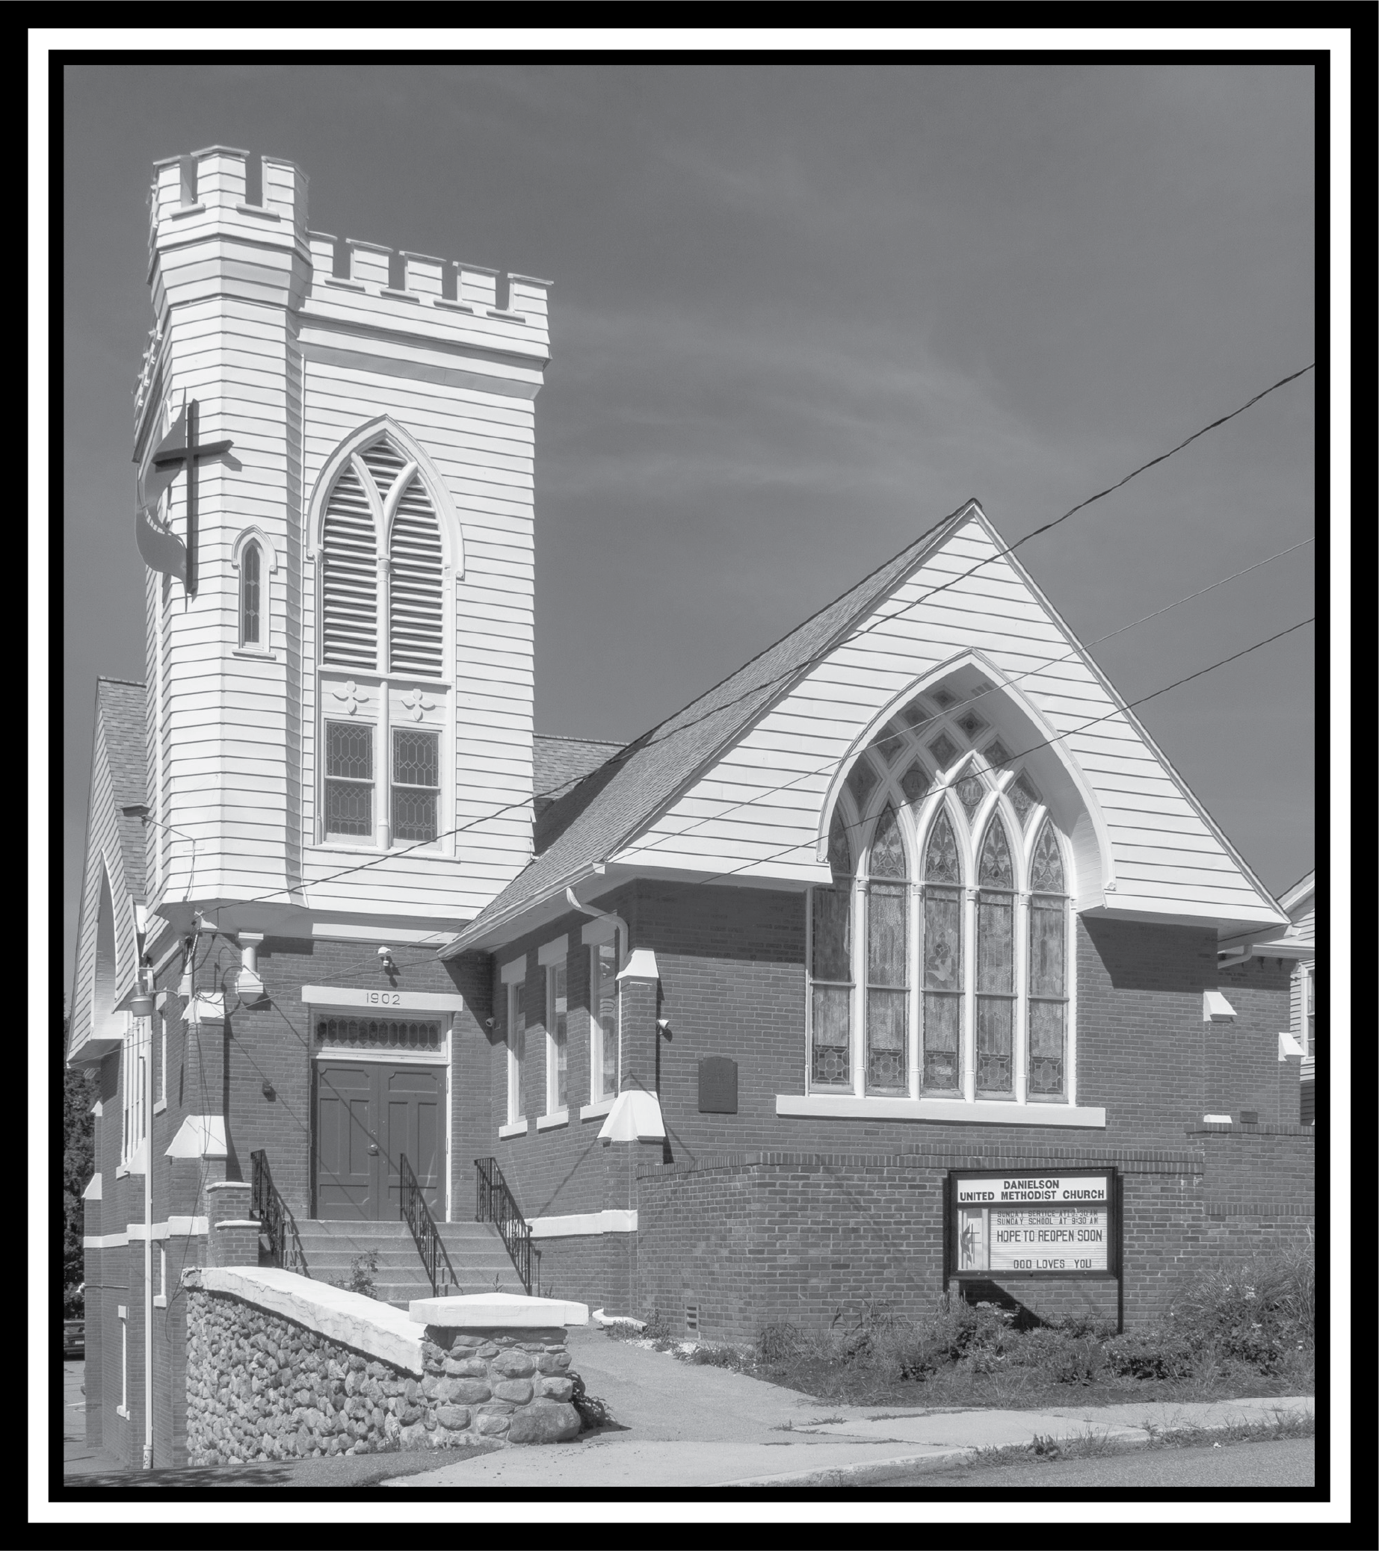

DANIELSON UNITED METHODIST CHURCH
Thank you for sharing your wonderful presence and voice with us this morning as we celebrate and worship the risen God.

Sunday, February 4, 2024
Fifth Sunday After Epiphany

