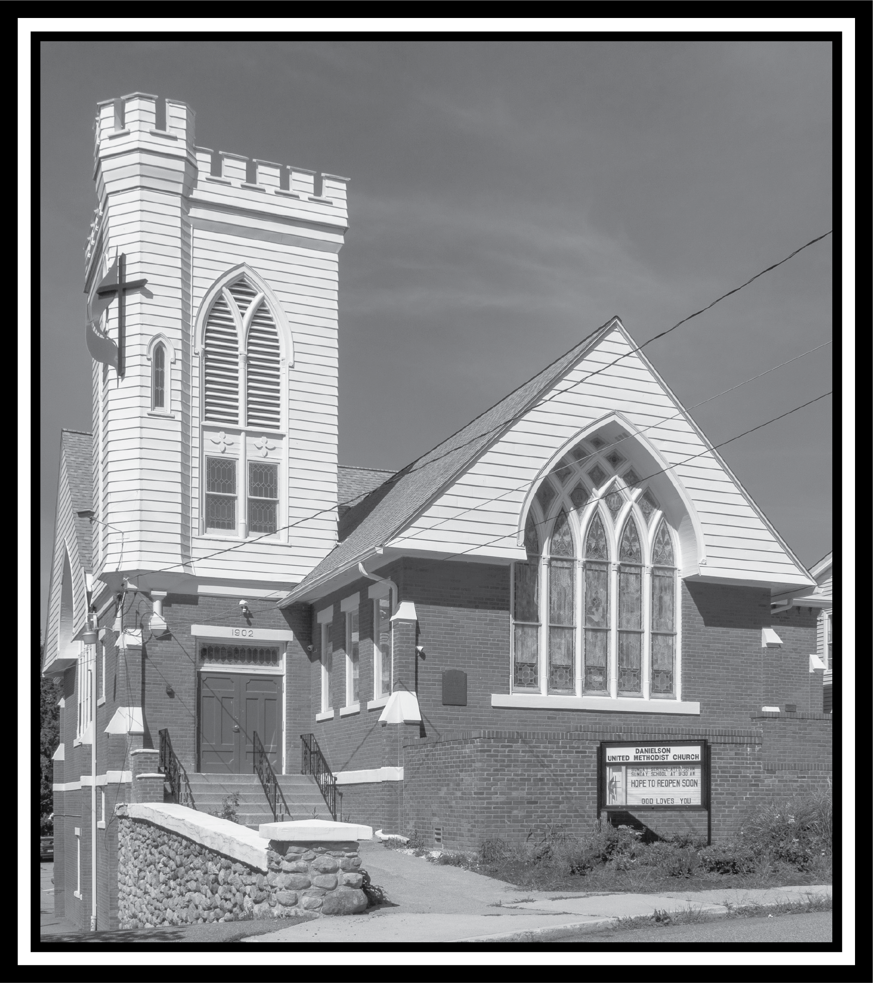

United Methodist Church of Danielson News
January
This Photo by Unknown Author is licensed under CC BY-NC-ND
January 2024 Article

This Advent, we talked a lot about ghosts. The ghost of Christmas, past, present, and yet to come. In previous years, there has generally been a lot of optimism around the new year, but I’ve recently noticed a decline. While there’s always a general hopefulness that remains, I haven’t encountered a lot of anticipation. Instead, there has been a fair bit of anxiety. (I mean, it is an election year) But is there something about the coming year that’s haunting us?
I will tell you what haunts me, sensationalist news headlines about the UMC breaking up. Perhaps you’ve seen them. “The United Methodist Comes Apart,” writes The New York Times. AP News says that “United Methodists are breaking up in a slow-motion schism.” And, according to Yahoo! News, “With a Deadline Looming, the United Methodist Church Breaks Up.” “‘It’s the biggest denominational schism ever,’ said Ryan Burge, a political scientist at Eastern Illinois University.”
Keep in mind, Dr. Burge, in addition to being an American Baptist pastor, (I love it when clergy are also professors) is a statistician, dealing in statistical data based on the best current available information. It is his job to analyze that data and offer the most plausible scenarios, such as Burge suggesting that in a decade, the 8 million Methodists in the U.S. in 2020 could drop by half in the next decade on account of “large-scale departures and the broader trend of decline.” This is in no way an attempt to discredit anything Dr. Burge is saying. Admittedly the current trends do point in that direction. But hear me when I say that the current predictions about what the future could be are simply that, predictions. Not the future writ large. And in the words we left Christmas Eve on, “The future can be changed.”
What will happen this year to our denomination, our conference, our district, and our church, I cannot say and will not say, because I don’t know. And neither does anyone else. Yet an even greater trend than church decline that I’ve seen is the habit of making decisions before all the information is in. Our faith tells us that God has an idea of what will transpire, but we certainly don’t. And maybe that’s what truly haunts us.
The fact is that we can’t know when all we want to do is know so that we’re ready for whatever comes our way. We hear the words of Jesus, “Beware, keep alert; for you do not know when the time will come” concerning his return (Mk 13:33, NRSV). This should be an indication that we don’t have to know when things will happen in order to be ready. That’s the whole point. Being ready isn’t knowing what’s coming, but having the ability to deal with whatever does come. But this involves training and conditioning. It involves living into Jesus’s words, “Do not worry about tomorrow, for tomorrow will bring worries of its own. Today’s trouble is enough for today” (Matt 6:34), and hear Moses’ words to Israel, “Be strong and bold; have no fear or dread of them, because it is the LORD your God who goes with you; he will not fail you or forsake you” (Deut 31:6).
James offers some good advice on how to be ready: “Who is wise and understanding among you? Show by your good life that your works are done with gentleness born of wisdom. But if you have bitter envy and selfish ambition in your hearts, do not be boastful and false to the truth. Such wisdom does not come down from above, but is earthly, unspiritual, devilish. For where there is envy and selfish ambition, there will also be disorder and wickedness of every kind. But the wisdom from above is first pure then peaceable, gentle, willing to yield, full of mercy and good fruits, without a trace of partiality or hypocrisy. And a harvest of righteousness is sown in peace for those who make peace” (3:13-18).
If we want to enter into this year, not anguished by the things that haunt us, but rather confident in facing them, then we should start here. Start with gentleness and peace. Is the church dividing and splitting and does the nation appear to be going that same way? Yes. But to go along with all that ultimately resigns us to disorder and wickedness and that isn’t what Jesus people are about. And again, the future can be changed. We don’t have to resign ourselves to that prediction. After all, as Jesus people, we are about grace, mercy and forgiveness, reconciliation and redemption, righteousness and truth. We are about peace, reason, and good fruit; not making decisions before all the [correct] information is in. These things possess the power of the Holy Ghost to transform hearts and dispel the hauntings of our past, present, and future. To face this New Year unafraid is my prayer for us, regardless of what happens within it. We can be ready because God has promised to come along too.
Happy New Year and see you in Church,
Pastor Zach

January Birthdays:
1/17 Sharon Perkins
1/18 Chris Martin
1/21 Milly Briggs
1/22 Joyce Davis
1/28 Nate Bramlett

Can you guess the mystery person????
This Photo by Unknown Author is licensed under CC BY
Clue:
I drove the bus for Roy Acuff (a Country Music singer) when I was in the Service.
Answer in the next edition
December’s mystery person was Sue Martin. Sue and her husband Chris were members of the Episcopal Church and came to us a couple of years ago. Sue teaches reading at KMS.
Sean Davis is nearing the end of his battle with ALS. Keep Joyce and Sean’s children and siblings in prayer as they deal with end of life.
Coffee time will now start at 10:15 so everyone has had a chance to get a coffee and a snack and some chat time. Sandy is organizing the coffee time and greeters.

Bible Study:

No bible study during January – Come join us in February on Saturday mornings at 9 AM. Online or at the church in the Christian Ed room.
This Photo by Unknown Author is licensed under CC BY-SA
What is Epiphany?
Epiphany refers to a Christian holy day celebrated on January 6th, which commemorates the visit of the Magi to the baby Jesus.
This Photo by Unknown Author is licensed under CC BY-NC-ND
Audits are completed!

Happenings at the church:
Sunday:
2 pm – Davis Place-1st Sunday of the month
2 – 3 pm: Al Anon (fellowship hall)
NA New Year’s Eve – 7 PM to 12 Midnight. After 1/1/2024 5:30 PM – 7 PM (fellowship hall)
Monday:
1 and 3 pm until further notice
(3rd Monday of the month) Killingly-Brooklyn Interfaith Council Meetings
Wednesday: 12 noon: Community Kitchens (fellowship hall)
Friday:
10:30 am – 12:30 pm
Diaper Bank Last Friday of the month
6:30 – 8pm: NA (fellowship hall)
Saturday: 9 – 10 am: Bible Study (Christian Ed Room / hybrid)
Monday, Tuesday and Wednesday evenings 5:30 pm – Jumping for Jesus exercise group
ZOOM Info:
To take part in our Sunday service or weekly bible study:
Zoom: https://us02web.zoom.us/j/84437849276
or call in by phone: 1 (646) 558-8656; ID: 844 3784 9276#

Leadership group:
Lay Leader: Cyndi Perkins
Admin. Asst.: Betsy Kneeland
Reverend: Zach LeCrone
Media Director: Cori Sharrow
Church Office: 860-779-2018
Pastor’s Cell: 217 840-1623
Things to put on your calendar:

Blood drive 1/6/2023 – 9 AM – 3 PM
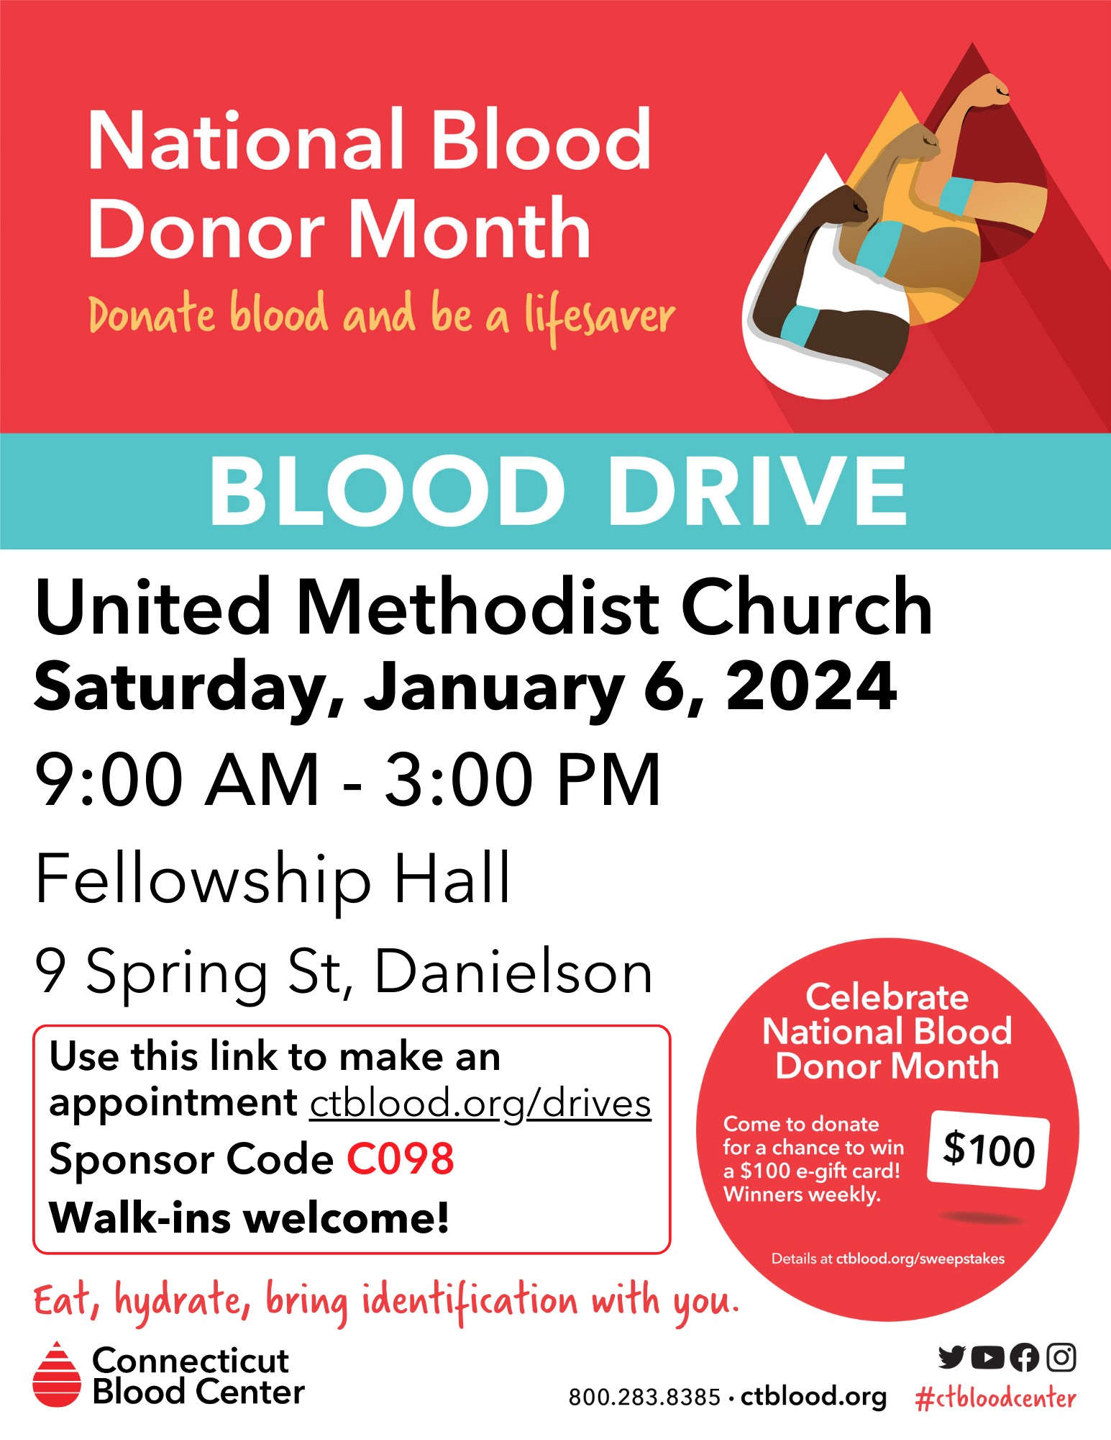

Next Mission Meeting 1/8/24 at 6:30 PM

Next Ad Council Meeting 1/8/24 at 7
PM

Visionary 2024 meeting – 1/27/2024 – 9 AM

Please feel free to share any of your special events: joys & celebrations, anniversaries, birthdays, special awards/honors, trips, etc.
Deadline for news items is the 10th of each month. Send info to umcd@snet.net.

It’s winter - be safe out there – weather cancellations will be broadcast on WFSB – Channel 3.

