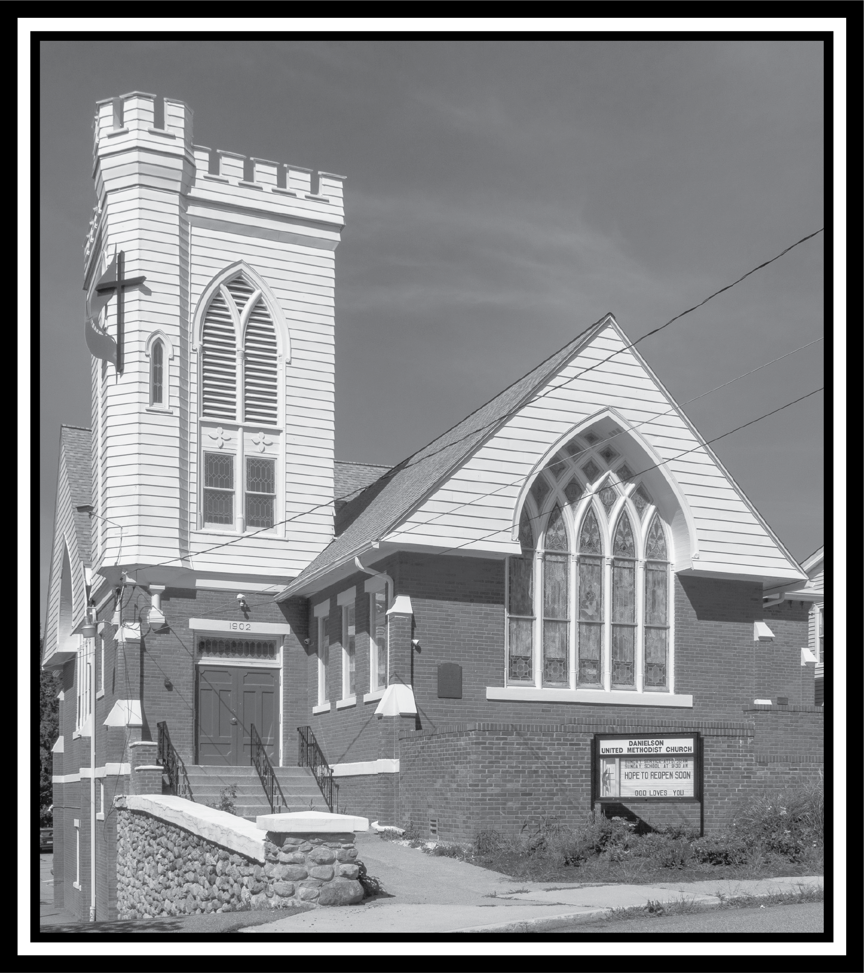

United Methodist Church of Danielson News
Franciscan tradition tells the story of St. Francis, while traveling one day, heard the voice of God. He had grown tired from being out in the sun all day, and sought shelter in a run-down chapel a mile outside of Assisi. In his book, Reluctant Saint, on the life of St. Francis of Assisi, Donald Spoto describes it this way,
“San Damiano was a small church, and over its doorway Francis could make out the faded words often inscribed in country chapels: Domus Mea (My House). Once inside, Francis sat alone, his eyes gradually adjusting to the dark. The place seemed on the verge of collapse from old age and neglect. The walls were cracked, the low vault was crumbling, the beams were rotting. Wild grass sprouted along a narrow window, and the crescent-shaped apse, once bright blue with painted stars, was faded and peeling. No one had worshiped at San Damiano for years. Over the abandoned altar, a crucifix had somehow survived the decay. Painted on linen stretched taut over a walnut frame, it was a striking image in the tradition of Syrian-influenced 12th-century iconography, the eyes of Christ gazing serenely and directly toward the viewer. In the stillness of the small church, Francis felt, … ‘different from when he had entered.’ And then, ‘the image of Christ crucified spoke to him in a tender and kind voice: ‘Francis, don’t you see that my house is being destroyed? Go, then, and rebuild it for me.’”
I love that story because I know little country churches like San Damiano; those old churches that have all but disappeared from years of neglect. Truth be told, it was my love for these kinds of churches that I entered ministry with the intention of being a solely local licensed pastor, because I figured that was where I would always be sent in that status.
My grandmother regularly worshiped in one of those churches, across the road from where she lived for many years, and my sister and I would attend with her when we would stay with her and my Granddad during the summer. I learned how to play music in front of people in that church. I learned the beauty of the United Methodist connection in that church because in their pews lived the same hymnals as the home church I worshiped in the rest of the year. That congregation sang the same hymns out of the same book, blessed communion with the same liturgy, said the same prayers and ordered their service in almost exactly the same way. And yet it was different. It was different because they were their own church, not mine. So I never thought about them being the same, only related. It’s how you go to your grandparents house. It’s obviously not your house, but it still feels like home somehow. That’s the way I feel about God’s house. God’s house isn’t our house, but it’s home.
I know we are all familiar with churches like San Damiano. Perhaps we see a bit of our own churches in that out of the wayness of the little chapel outside the city walls, with her cracked walls, crumbling ceilings and rotting beams. But it was in this setting, not the main church in town, where God spoke tenderly and kind to Francis.
While Francis took the message literally and began to repair the broken down chapel, he also understood it to be a metaphor for needed reform in the vastly influential 13th century Catholic Church. And while Francis did seek out permission from Rome to begin his monastic order and traveled to the Holy Land to meet with a Muslim leader during the 5th Crusade, he started his repair and reform of the Church right there in that broken down chapel.
I wonder how many of us have heard that tender and kind voice of God here lately concerning the issues of the Church in our own day? Debates over holiness and human sexuality, greed, marginalization, racism, etc. have all become the bane of our existence. Vital ministry is happening in our churches around these issues, but all the news wants to talk about is the break-up of the United Methodist Church over them instead of the work we are doing to respond to them. I think we have indeed heard God say to us, “Don’t you see my house is being destroyed? Go, then, and rebuild it for me.”
The United Methodist Church is so much more than a denomination, it is a house, a home for so many. But the cracked walls, the crumbling ceilings and rotting beams are showing. The wild grass is growing in the windows and the paint is peeling. It is obvious that in numerous ways the house is being destroyed. We need to get to rebuilding.
We don’t need to go anywhere to begin this work, however. We don’t need to go to our UM Center in Nashville or to the General Conference at the end of April. We can start with our own churches, our own windows, ceilings, beams, hearts and heads. I take great comfort in the words of Jesus to Simon Peter when the apostle made that initial statement of faith, “You are the Messiah, the Son of the Living God.’ And Jesus answered him, ‘Blessed are you, Simon son of Jonah! For flesh and blood has not revealed this to you, but my Father in heaven. And I tell you, you are Peter, and on this rock I will build my church, and the gates of Hades will not prevail against it” (Matt 16:16-18, NRSV). Jesus didn’t build his church on a physical building or an institution, he built it on a flesh and blood person. A doubting, denying, confused devil of a person. Peter. So don’t feel inadequate for such a task. Jesus invested in people and Jesus has invested in you.
What we don’t have to figure out is where God is in all of this. For God is like that crucifix that somehow survived. God was still in that space. God, among the wild grass in the windows and peeling paint, spoke a mission to Francis. And every week God speaks a mission to us: “Go, then, and rebuild it for me.” “Go, therefore, and make disciples”(Mt 28:19). “Cure the sick, raise the dead, cleanse the lepers and cast out demons. You received without payment; give without payment” (Mt 10:8) “Abide in me as I abide in you. Just as the branch cannot bear fruit by itself unless it abides in the vine, neither can you unless you abide in me. I am the vine, you are the branches. Those who abide in me and I in them bear much fruit, because apart from me you can do nothing” (Jn 15:4-5).
Let us respond to God’s call to rebuild by bearing curing, raising, cleansing, and bearing fruit. Let us abide in the vine. Let us go, then, and rebuild God’s house, our home together.
See you in Church,
Pastor Zach
March Birthdays:
3/7 Annie Perkins
3/8 Connie Viveiros
3/ Missy Wrigley
3/9 Nancy Gaudreau
3/30 Elizabeth Hoyt
This Photo by Unknown Author is licensed under CC BY-NC
Happy St. Patrick’s Day
Can you guess the mystery person????
This Photo by Unknown Author is licensed under CC BY
Clue:
I was a puppeteer
Answer in the next edition
February’s mystery person was Barbara Schreier. Barbara grew up in Woodstock. She maintains the Fuel Bank office and helps with Community Kitchens.
Sean Davis is nearing the end of his battle with ALS. Keep Joyce and Sean’s children and siblings in prayer as they deal with end of life.
Coffee time will now start at 10:15 so everyone has had a chance to get a coffee and a snack and some chat time. Sandy is organizing the coffee time and greeters.

Lent starts on February 14
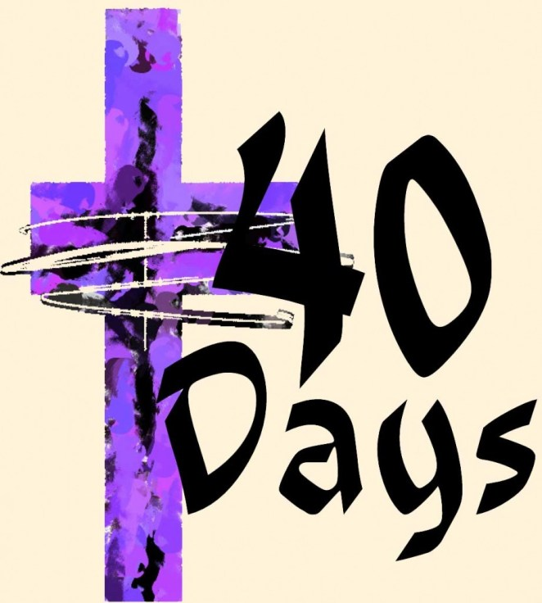
This Photo by Unknown Author is licensed under CC BY-NC-ND

This Photo by Unknown Author is licensed under CC BY-SA-NC

Bible Study:

Join us in February on Saturday mornings at 9 AM starting on 2/17. Online or at the church in the Christian Ed room.
Lenten Study - “How Did We Get Here?”
We will kick-off a look at the current state of our United Methodist Church, starting Saturday, February 17, 2024. As you have probably seen and heard in both conference and national news, the UMC has just emerged from a season of disaffiliation that saw 25% of churches leave the connection. How we got here and where we go as a denomination as we await the General Conference in the Spring is the topic of this study.
We will look at the history of how the denomination has handled the questions surrounding human sexuality. We will wrestle with the hurt caused during this season. We will also flex our theological muscles as we consider where we land as individuals and as a church in “a time such as this.”
There is nothing to purchase. All weekly readings will be emailed to anyone who wishes to participate. Please let Pastor Zach or Cyndi know if you intend on joining in so materials can be sent to you.
This Photo by Unknown Author is licensed under CC BY-SA-NC
World Day of Prayer – Saturday, 3/2/2024 Please RSVP to the church at 860 779-2018.

The Danielson United Methodist Church, 9 Spring St., will be holding a World Day of Prayer service written by Christian Women of Palestine. The program starts with a Palestinian luncheon at noon, followed by the service of scripture and song around the theme, "Bear with one another in love".
2023 Audit is done. One less thing when Church Conference comes around.
Happenings at the church:
Sunday:
2 pm – Davis Place-1st Sunday of the month
2 – 3 pm: Al Anon (fellowship hall)
NA New Year’s Eve – 7 PM to 12 Midnight. After 1/1/2024 5:30 PM – 7 PM (fellowship hall)
Monday:
1 and 3 pm until further notice
(3rd Monday of the month) Killingly-Brooklyn Interfaith Council Meetings
Wednesday: 12 noon: Community Kitchens (fellowship hall)
Friday:
10:30 am – 12:30 pm
Diaper Bank Last Friday of the month
6:30 – 8pm: NA (fellowship hall)
Saturday: 9 – 10 am: Bible Study (Christian Ed Room / hybrid)
Monday, Tuesday and Wednesday evenings 5:30 pm – Jumping for Jesus exercise group
ZOOM Info:
To take part in our Sunday service or weekly bible study:
Zoom: https://us02web.zoom.us/j/84437849276
or call in by phone: 1 (646) 558-8656; ID: 844 3784 9276#

Leadership group:
Lay Leader: Cyndi Perkins
Admin. Asst.: Betsy Kneeland
Reverend: Zach LeCrone
Media Director: Cori Sharrow
Church Office: 860-779-2018
Pastor’s Cell: 217 840-1623
Things to put on your calendar:

2/11 – Souper Bowl

Next Mission Meeting 3/11/24 at 6:30 PM

Next Ad Council Meeting 3/11/24 at 7
PM

Please feel free to share any of your special events: joys & celebrations, anniversaries, birthdays, special awards/honors, trips, etc.
Deadline for news items is the 10th of each month. Send info to umcd@snet.net.

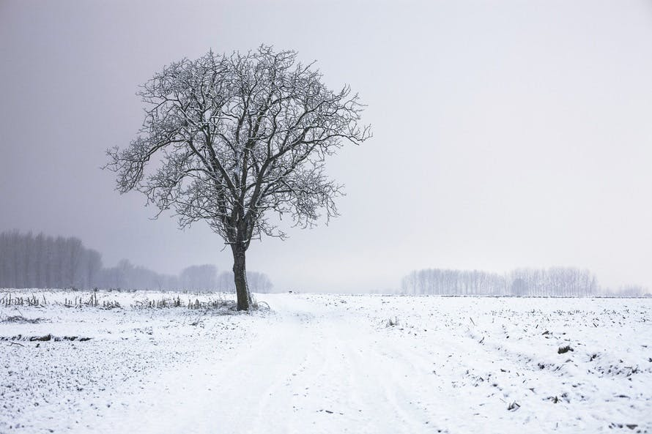

It’s winter - be safe out there – weather cancellations will be broadcast on WFSB – Channel 3.

Turn the clocks back on March 10

