Welcome. In this place know that you are loved. No matter what you have done or left undone, said or left unsaid, or shame you carry, you are a child of God and most welcome here. May this time together in worship be one of peace, hope, and love.

GATHERING TOGETHER
GREETING/ANNOUNCEMENTS Betsy Kneeland
RINGING OF THE BELL Cori Sharrow
CALL TO WORSHIP
Lenten travelers, the journey is long. Let us take a moment to rest and breathe.
Only in God do we find our rest.
Sometimes the road is easy, and we bask in the warmth of the Light who guides us.
Other times the road is hard, and we hide from the Light, afraid for our actions to be made known in public.
Somedays we delight in the joy of journeying together on this road.
Other days we struggle with the temptation to judge and condemn one another as we travel this path.
Today, let us come into the Light together as we learn to love God and one another through the twists and turns of our Lenten journey.
Come, let us worship God together! Amen.
Written by Dr. Lisa Hancock, Discipleship Ministries, October 2023.
HYMN: Amazing Grace UMH #378
CHILDREN’S MOMENTS Cyndi Perkins
MUSICAL RESPONSE Jesus Loves Me Congregation
HYMN: Rock Of Ages UMH #361
HEARING GOD’S WISDOM
FIRST READING Numbers 21:4-9, NRSVUE

SPECIAL MUSIC Pastor Zach
SECOND READING John 3:14-21, NRSVUE Pastor Zach
The Apostle’s Creed UMH #881
MORNING MESSAGE Pastor Zach
RESPONDING IN FAITH
PRAYERS OF THE PEOPLE The Keehners
Sue: Jesus, you have known us from the beginning of time, you have known us in the depths of our dreams and in the darkness of our shame, you know us as your beloved.
Fred: Help us to own that core identity more and more in this season of repentance and mercy. Give us the rock-solid assurance of your unwavering faith in us as we seek the same in you. Amen.
Author Unknown
SHARING JOYS AND CONCERNS Pastor Zach
LORD’S PRAYER Aby O’Brien
OFFERING Pastor Zach
I wish to thank everyone on behalf of our church who give online, by mailing a check, or give in the offering plate. We should all remember the words of the Lord Jesus, it is more blessed to give than to receive. Now Let us pray.
OFFERING PRAYER Pastor Zach
God of unwavering love, you have held nothing back in your love for us, not even your Son. How we marvel at that kind of love, and how we long to reflect a portion of that devotion back to you. As we dedicate our offerings to you, lead us away from our tendency to hold back and worry that there will not be enough. Help us to live as the people of love and abundance you have called us to be. In Christ, we pray. Amen. (John 3:14-21)
DOXOLOGY
HYMN: Because He Lives UMH #364
GOING FORTH TO MAKE DISCIPLES
BENEDICTION Pastor Zach

ANOTHER WEEK IN THE WORLD:
Sunday: 2 PM – Davis Place-1st Sunday of the month
2 – 3 PM: Al Anon (fellowship hall)
5:30 – 7 PM: NA (fellowship hall)
Monday: 1 and 3 pm until further notice (3rd Monday of the month) Killingly-Brooklyn Interfaith Council Meetings
Wednesday: 12 noon: Community Kitchens (fellowship hall)
Friday: 10:30 am – 12:30 pm – Diaper Bank Last Friday of the month
6:30 – 8pm: NA (fellowship hall)
Saturday: 9 – 10 am: Bible Study (Christian Ed. room / hybrid)
Monday, Tuesday and Wednesday evenings 5:30 pm –
Jumping for Jesus exercise group

To take part in our Sunday service or weekly bible study:
Zoom: https://us02web.zoom.us/j/84437849276
or call in by phone: 1 (646) 558-8656; ID: 844 3784 9276#

PRAYER CONCERNS:

For all those who are needing God’s healing hand

Lay Leader: Cyndi Perkins
Admin. Asst.: Betsy Kneeland
Reverend: Zach LeCrone
Media Director: Cori Sharrow
Church Office: 860-779-2018 Pastor’s Cell: 217 840-1623
Church Weekly Newsletter Sign Up: umcd@snet.net

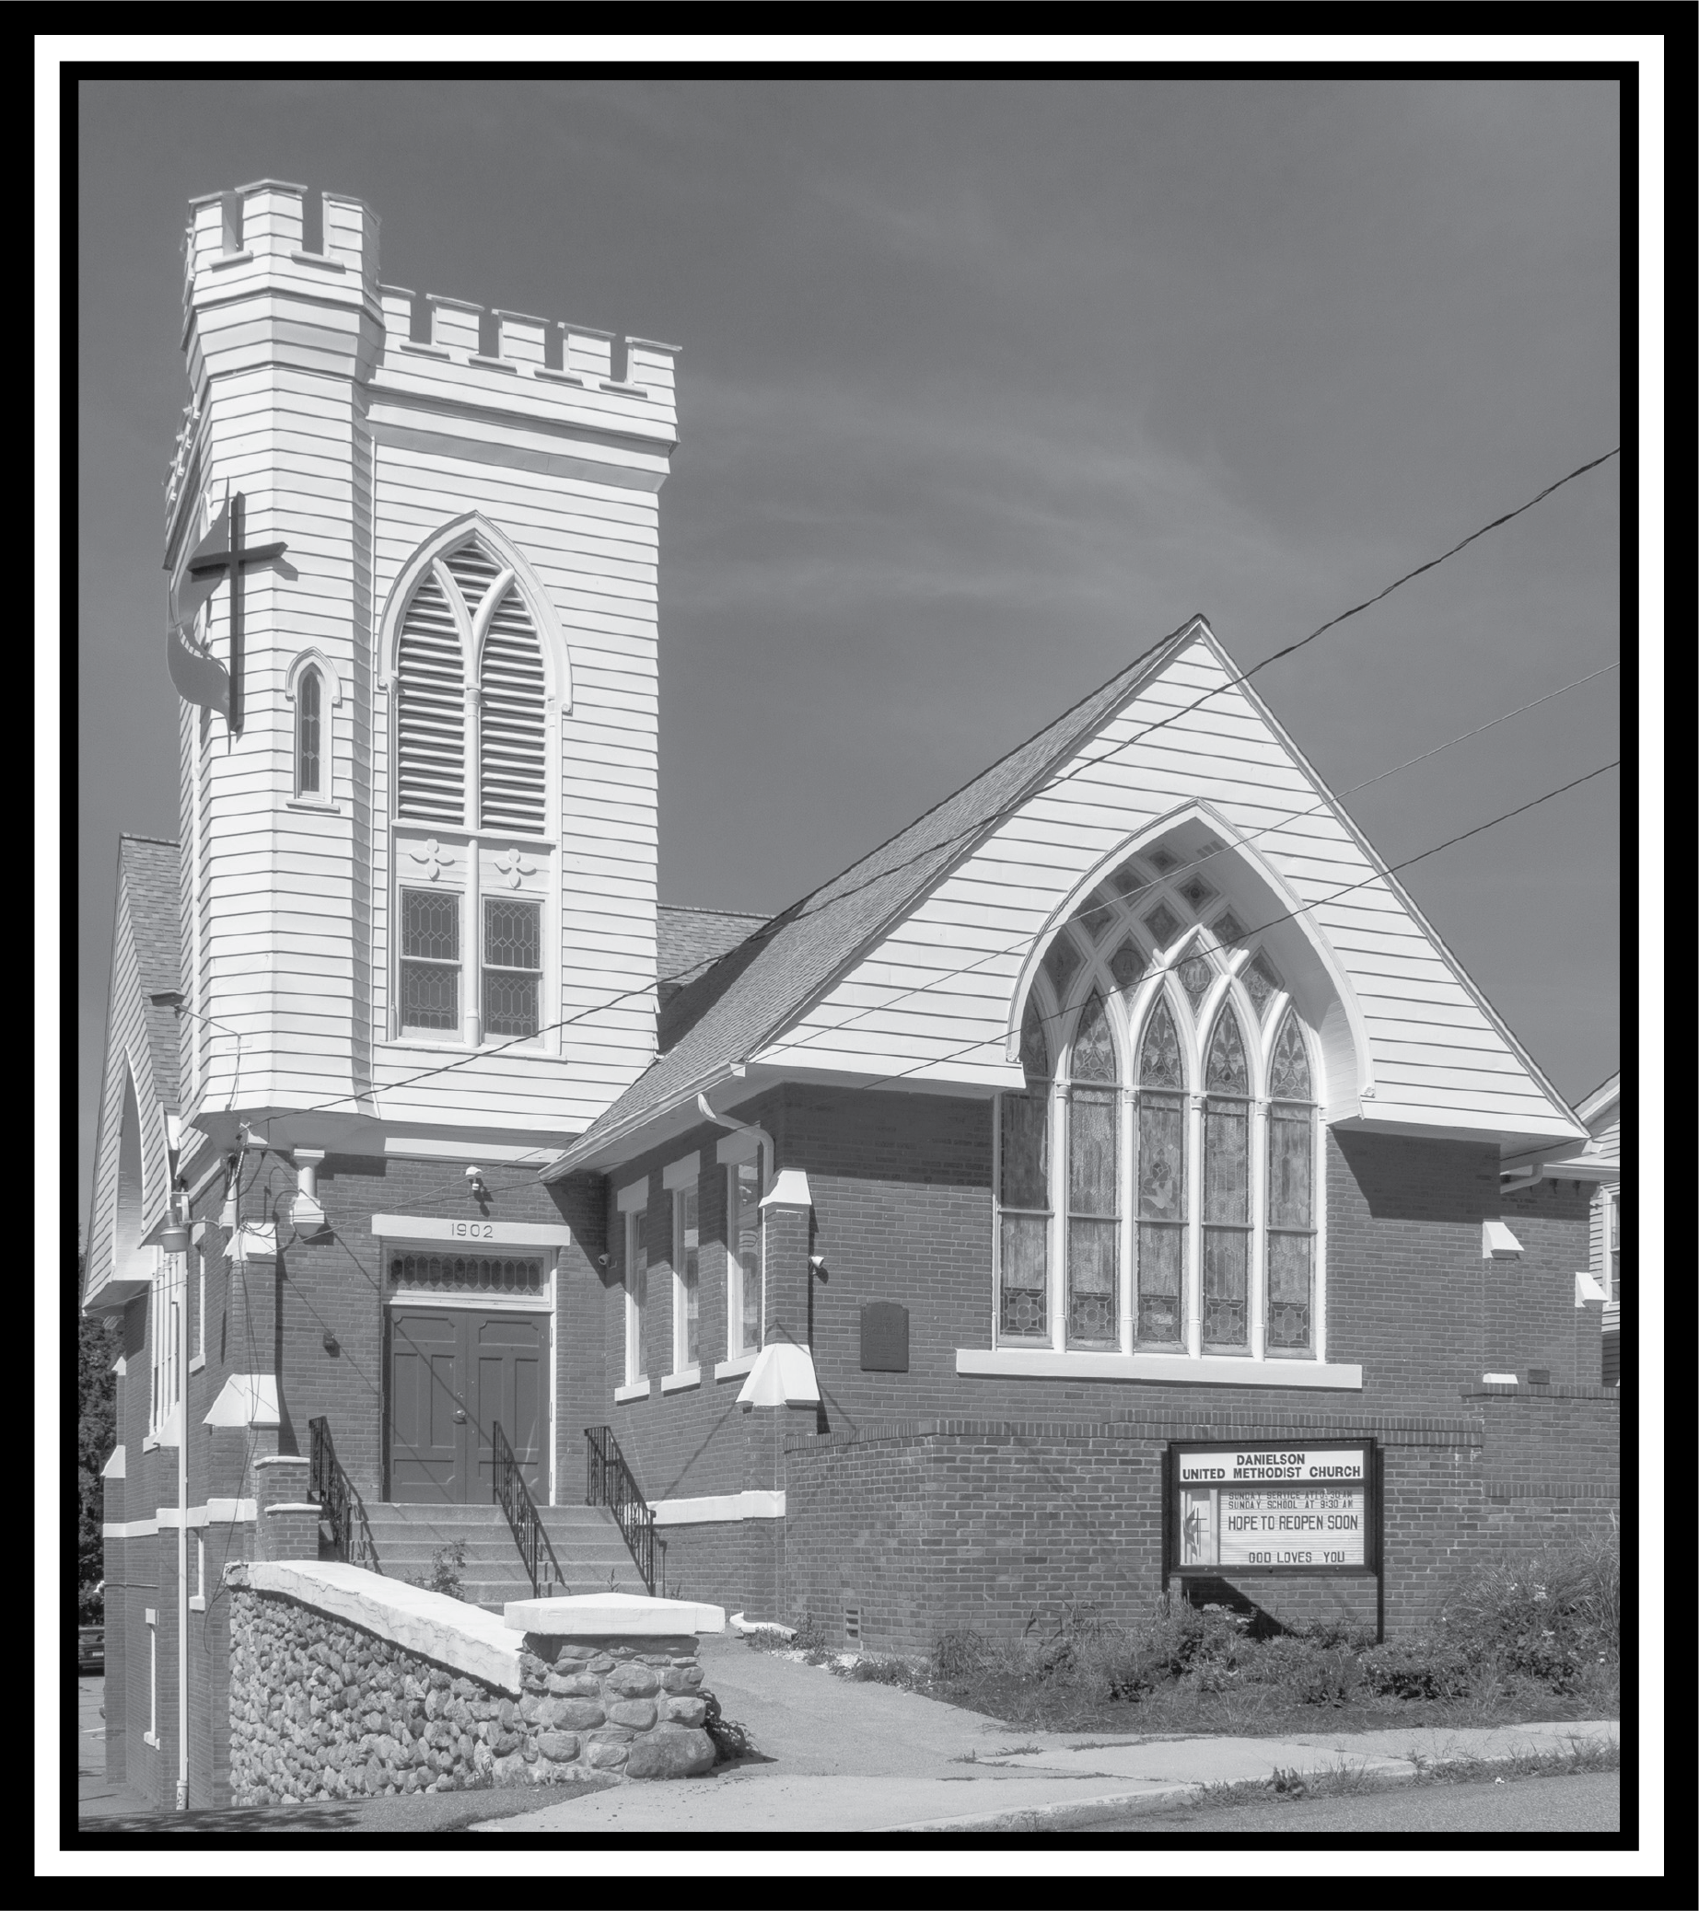

DANIELSON UNITED METHODIST CHURCH
Thank you for sharing your wonderful presence and voice with us this morning as we celebrate and worship the risen God.

Sunday, March 10, 2024
Fourth Sunday of Lent

