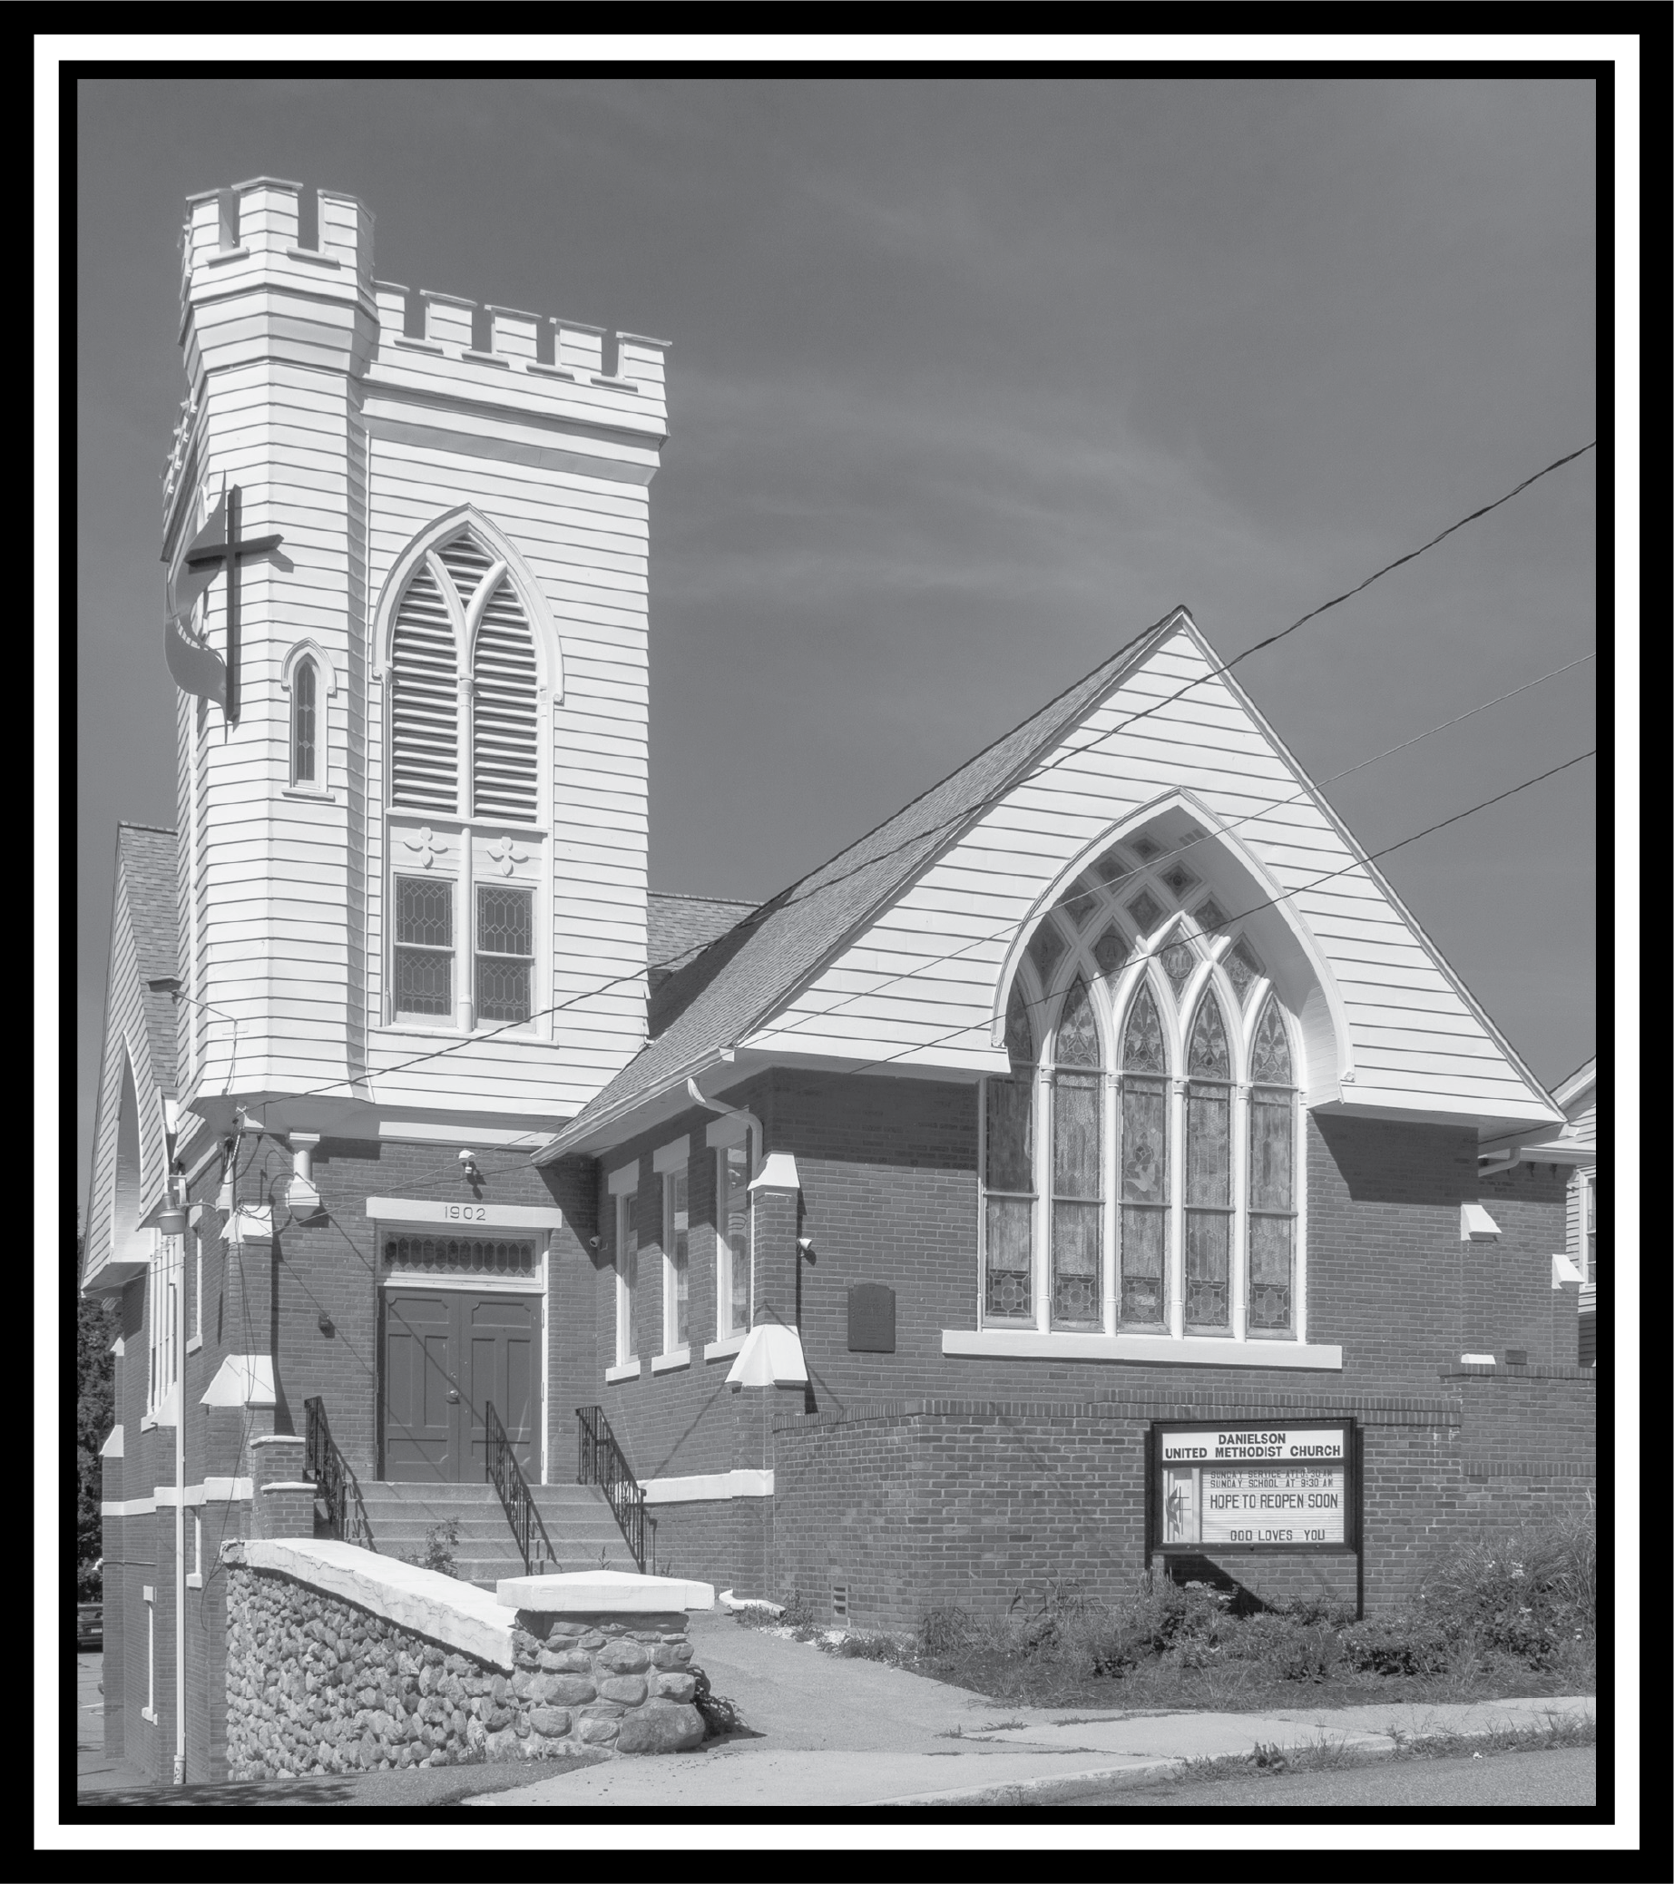

United Methodist Church of Danielson News
In his book, For the Sake of the Bride: Restoring the Church to Her Intended Beauty, United Methodist scholar Steve Harper shares how his 2014 Lenten experience “included the clear call to become spiritually near-sighted for a season, so that a spirit of confession and repentance might take the place of condemnation and degradation.” It is in the spirit of such transformation that we enter another Lenten season; hopefully one that leads us away from “looking over the fence into the yards of others” so that we might more plainly “see the weeds in our own.”
Lent, after all, is a season for self-reflection, traditionally commemorating the forty days and forty nights Jesus spent in the wilderness. The Gospels tell us that while there, the devil tempted Jesus. Alone in that desolate space, writes W. Paul Jones, the devil offers Jesus “possessions, prestige, and power” (Matt 4; Luke 4)— turn stones into bread, jump off the temple, and rule the world. Possessions, prestige, and power. The opportunity to look over the fence into someone else’s yard for weeds while standing in our own.
While we may have grown up being told that discipleship can involve “bringing back a sinner from wandering” (James 5:20, NRSV) such a task is full of pitfalls and trapdoors. While we work for reconciliation, we are always to do so “with a spirit of gentleness” for the risk of being tempted ourselves is always near (Gal 6:1). Therefore any corrections must be offered in a spirit of charity and care in order to “Bear one another’s burdens” properly (Gal 6:2). Therefore we must ask ourselves as Paul asked the Romans, “Why do you pass judgment on your brother or sister? … why do you despise your brother or sister? For we will all stand before the judgment seat of God. For it is written,
‘As I live, says the Lord, every
Knee shall bow to me,
and every tongue shall give
praise to God.’
So then, each of us will be accountable to God” (Rom 14:10b-12)
As we can see, the devil had no authority to demand Jesus bow down to him, or offer any of the things he promised. Only God could name Jesus “ruler of kings on earth” because Jesus did bow. Not to the devil, but to God, as “the faithful witness” and “firstborn of the dead” (Rev 1:5).
Neither Satan, nor sin possess the power to do anything eternally good in this world, and that includes our individual lives. While possession, prestige, and power may provide the fleeting opportunity to look over the fence into the yard of others, we have no authority over our neighbor, save that which God has given - the authority to love them as we love ourselves (Mark 12:31), to care for them as we care for ourselves (James 2:14-17). Something to consider deeply as we move through this election year.
This is a time to turn inward, “to become spiritually near-sighted for a season so that a spirit of confession and repentance might take the place of condemnation and degradation.” May we resist the temptations of possessions, prestige, and power, the desire to peek over the fence, so that we can commit to searching out the weeds in our own yards. If we commit to this, at the end of the season, we are sure to find the one Mary thought was the gardener, the One who was tempted just as we are, working alongside us.
See you in church,
Pastor Zach

February Birthdays:
2/2 Kendra Collins
2/5 Mary Ellen Goettel
2/14 Cassie Sleboda
2/15 Emilie LeCrone
2/20 Sheila Richardson

Happy Valentine’s Day
Can you guess the mystery person????
This Photo by Unknown Author is licensed under CC BY
Clue:
I showed cattle for 4-H
Answer in the next edition
January’s mystery person was Richard Perkins. Dick grew up in this church. He left for years and then came back in the 80’s. I drove Roy Acuff’s bus while in the service in France and Germany.
Sean Davis is nearing the end of his battle with ALS. Keep Joyce and Sean’s children and siblings in prayer as they deal with end of life.

Coffee time will now start at 10:15 so everyone has had a chance to get a coffee and a snack and some chat time. Sandy is organizing the coffee time and greeters.
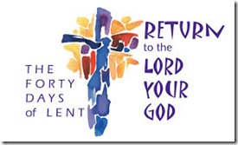
This Photo by Unknown Author is licensed under CC BY-ND
Lent starts on February 14

This Photo by Unknown Author is licensed under CC BY-SA-NC

Bible Study:

Join us in February on Saturday mornings at 9 AM starting on 2/17. Online or at the church in the Christian Ed room.
Lenten Study - “How Did We Get Here?”
We will kick-off a 5-week look at the current state of our United Methodist Church, starting Saturday, February 17, 2024. As you have probably seen and heard in both conference and national news, the UMC has just emerged from a season of disaffiliation that saw 25% of churches leave the connection. How we got here and where we go as a denomination as we await the General Conference in the Spring is the topic of this study.
We will look at the history of how the denomination has handled the questions surrounding human sexuality. We will wrestle with the hurt caused during this season. We will also flex our theological muscles as we consider where we land as individuals and as a church in “a time such as this.”
There is nothing to purchase. All weekly readings will be emailed to anyone who wishes to participate. Please let Pastor Zach or Cyndi know if you intend on joining in so materials can be sent to you.

2023 Audit is scheduled for 2/16.

Happenings at the church:
Sunday:
2 pm – Davis Place-1st Sunday of the month
2 – 3 pm: Al Anon (fellowship hall)
NA New Year’s Eve – 7 PM to 12 Midnight. After 1/1/2024 5:30 PM – 7 PM (fellowship hall)
Monday:
1 and 3 pm until further notice
(3rd Monday of the month) Killingly-Brooklyn Interfaith Council Meetings
Wednesday: 12 noon: Community Kitchens (fellowship hall)
Friday:
10:30 am – 12:30 pm
Diaper Bank Last Friday of the month
6:30 – 8pm: NA (fellowship hall)
Saturday: 9 – 10 am: Bible Study (Christian Ed Room / hybrid)
Monday, Tuesday and Wednesday evenings 5:30 pm – Jumping for Jesus exercise group
ZOOM Info:
To take part in our Sunday service or weekly bible study:
Zoom: https://us02web.zoom.us/j/84437849276
or call in by phone: 1 (646) 558-8656; ID: 844 3784 9276#

Leadership group:
Lay Leader: Cyndi Perkins
Admin. Asst.: Betsy Kneeland
Reverend: Zach LeCrone
Media Director: Cori Sharrow
Church Office: 860-779-2018
Pastor’s Cell: 217 840-1623
Things to put on your calendar:

2/11 – Souper Bowl

Next Mission Meeting 3/11/24 at 6:30 PM

Next Ad Council Meeting 3/11/24 at 7
PM

Please feel free to share any of your special events: joys & celebrations, anniversaries, birthdays, special awards/honors, trips, etc.
Deadline for news items is the 10th of each month. Send info to umcd@snet.net.

It’s winter - be safe out there – weather cancellations will be broadcast on WFSB – Channel 3.

